**AutoCAD 2017 Instructional Videos**

**Chapter 1: Drawing in AutoCAD**

**User Interface**

1. What is AutoCAD?

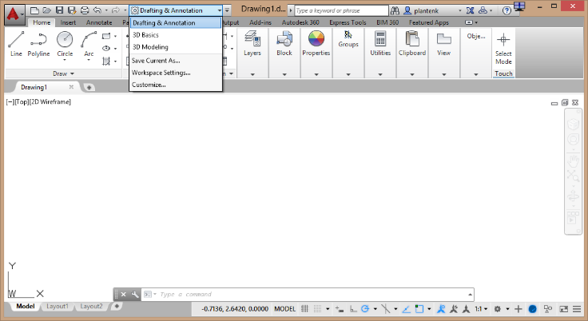Hi and welcome to Engineering Essential’s AutoCAD instruction. In this episode we will be taking a look at AutoCAD’s user interface. AutoCAD is a drawing package. It allows you to draw both 2-D and 3-D objects. The commands used to create a 2-D object are different from those used to create a 3-D objects, therefore AutoCAD has created two main workspaces. One for creating 2-D drawing and one for creating 3-D drawings. The *Drafting & Annotation* workspace is used to create 2-D drawings, and the *3D Modeling* workspace is used for creating 3D objects. You can access the different workspaces within the *Quick access toolbar*. Right now my toolbar is mostly hidden because my AutoCAD window is small for recording purposes.

1. Drafting & Annotation Workspace - Selecting commands

* Ribbon

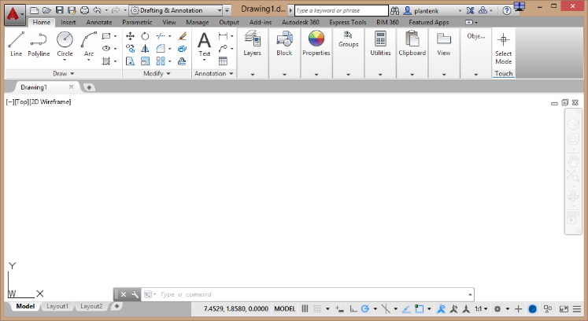At the moment, we are in the *Drafting & Annotation* workspace. The main purpose of this workspace is to draw and annotate 2D objects. The most frequently used method for accessing commands in this workspace is through the ribbon (highlight ribbon). The ribbon contains several panels. Each panel contains a group of similar commands. For example, the *Draw* panel contains commands that allow you to draw line, circles, and arcs along with many other shapes (highlight draw panel). The *Modify* panel commands allow you to modify objects after they have been drawn (highlight modify panel).

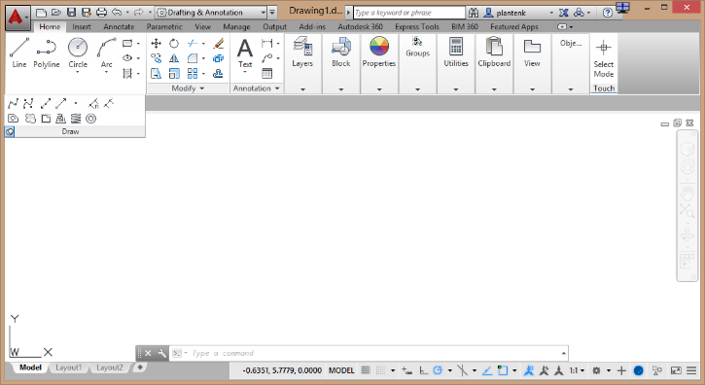Many panels have hidden commands that may be accessed by clicking on the black arrow next to the panel name. Notice that when the mouse moves off the panel, the commands collapse again. If you don’t want this to happen, you can pin the panel.

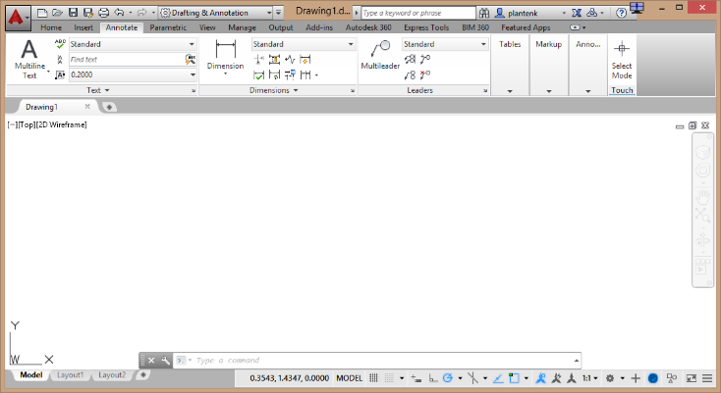Since there are so many commands available, there is no way to show them all at once, therefore they have been separated into different ribbon tabs (click on tabs).

* Tooltips

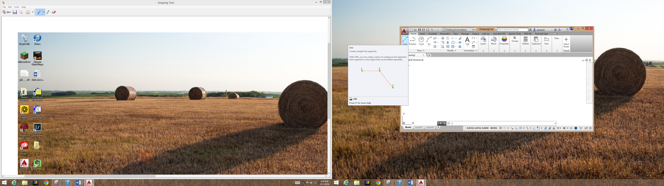If you are unfamiliar with a command, AutoCAD has supplied tooltips. Hover your mouse over a command icon and a short tooltip will appear. Keep the mouse there and the tooltip will expand to show more information.

* Command window

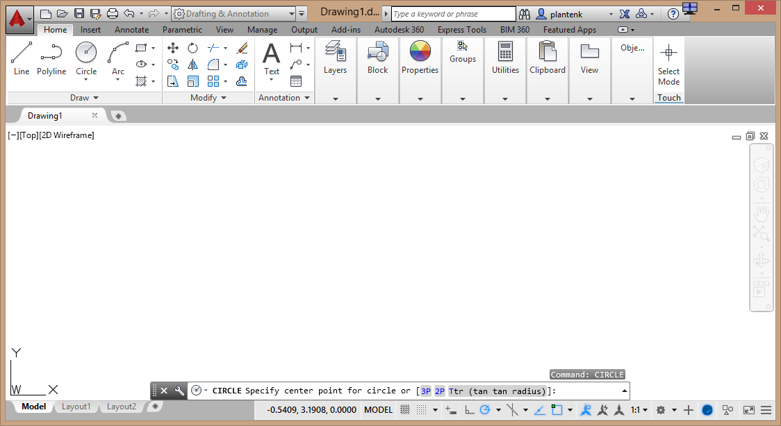Another way to access commands is through the command window or prompt (highlight command window). This is an area where you can type commands. AutoCAD has made this very logical and easy to use. If you want to draw a line, type the command LINE. If you want to draw a circle, type the command CIRCLE and so on. I find that spend at least 50% of my time entering commands in the command window. Not everyone likes to type commands, but I first learned AutoCAD when there were no icons, so I formed a habit of typing commands. Let’s try it out and draw a circle. Notice that once you have entered a command, AutoCAD will prompt you with what it expects next. I need to select a center point. Now I need to enter a radius. What if I don’t want to enter a radius? I can tell AutoCAD that I want to enter a diameter instead. If you want to repeat the last command used, just hit the space bar.

* 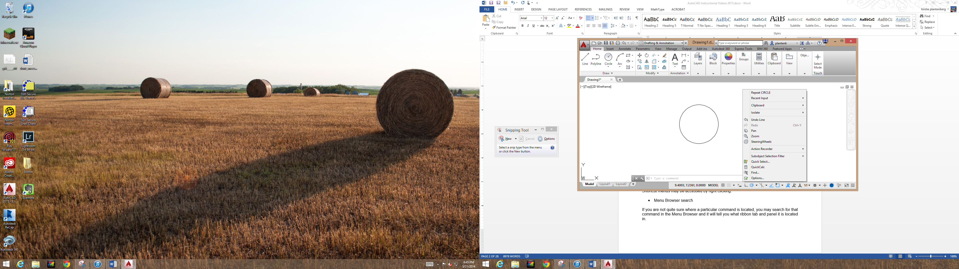Shortcut menus

Shortcut menus may be accessed by right clicking.

* Menu Browser search

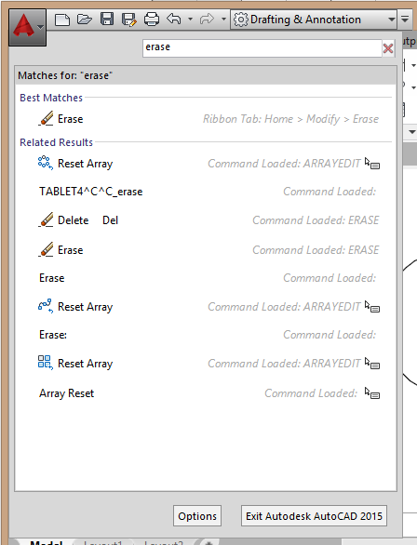If you are not quite sure where a particular command is located, you may search for that command in the Menu Browser search field and it will tell you what ribbon tab and panel it is located in.

* Tool pallets

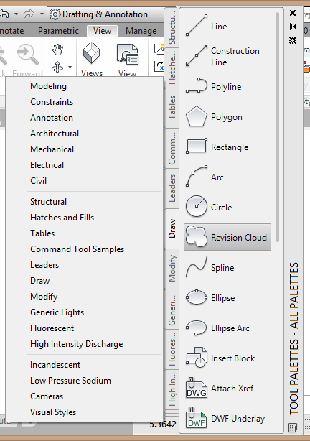Another method of accessing commands is through the tool pallets (access the tool pallets). The tool pallets contain all the commands that the ribbon does, with the addition of some engineering specific pallets (click on them).

* Status bar and Quick access toolbar

There are two toolbars that I use a lot. The first one is the *Status Bar* and the other is the *Quick Access* toolbar which we briefly used previously. The *Status Bar* is an area that holds drawing aid commands that are frequently turned on and off such as GRID and SNAP. The *Quick Access* toolbar may be customized to hold any command you like. However, it usually holds commands such as open, save, print and so on.

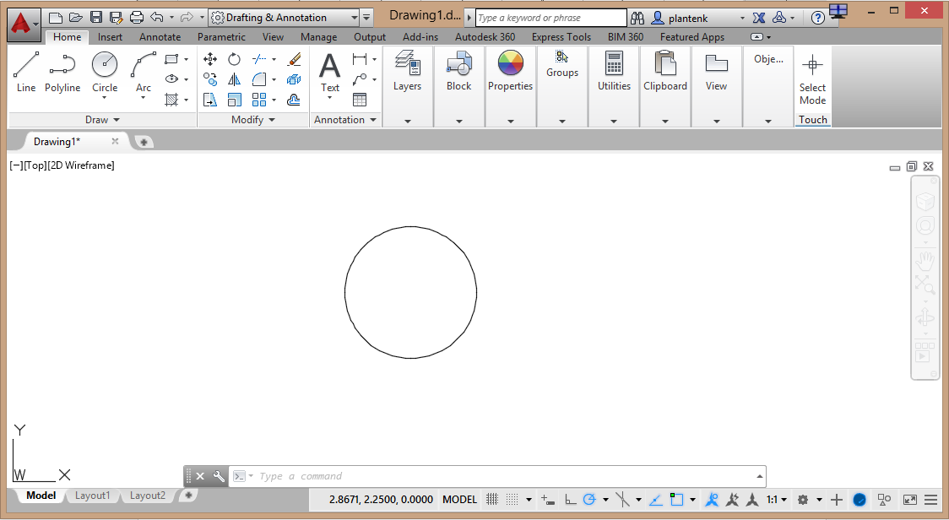

1. Starting a new drawing

Now that we have taken a look around AutoCAD’s user interface, you would probably like to start a new drawing and get to work. Click on the new icon in the *Quick Access* toolbar. A *Create New Drawing* window will appear. This will take you through setting up your units, paper size and more.

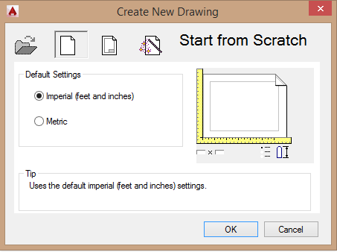 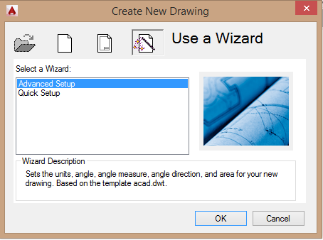

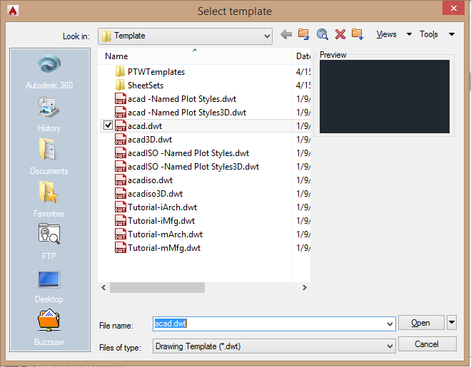Some users like to start from a drawing template. AutoCAD has many to choose from. We will need to change your STARTUP variable from 1 to 0. Now when we start a new drawing we get a *Select a Template* window.

1. Useful commands

There are two very useful commands that we should talk about. The first one is UNITS. This allows you to set your drawing units and number of decimal places. The other is LIMITS. This one defines the size of your paper. When setting your limits, the lower left corner should always remain 0,0.

1. 3D Modeling workspace

Before we end this episode, let’s enter the 3D Modeling workspace. Notice that the commands are very different. They are all related to constructing a 3D object.

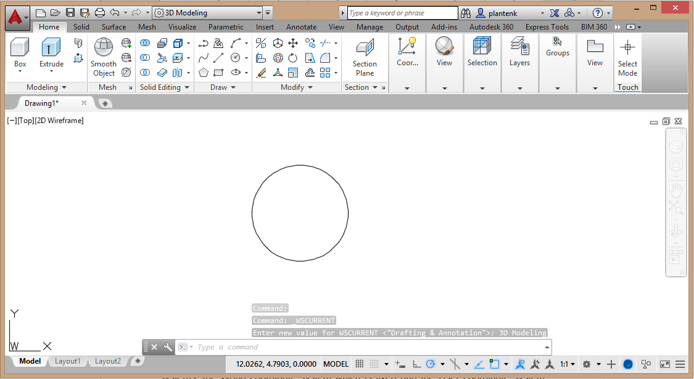

Have fun and explore. I’ll catch you in the next episode.

**UCS**

1. AutoCAD’s coordinate systems

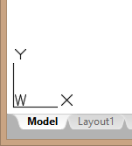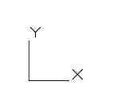Hi and welcome to Engineering Essential’s AutoCAD instruction. In this episode we will be taking a look at AutoCAD’s coordinate systems. AutoCAD has two coordinate systems, the *World Coordinate System* which is fixed and the *User Coordinate System* which can translate and rotate. Look in the bottom left corner of the drawing area. AutoCAD display an x-y coordinate axis (highlight axis). Notice that it has a W by the origin (highlight box). This indicates that we are in the World coordinate system. If I move the axis, and enter the User coordinate system, the W disappears.

Let’s re-enter the WCS or World coordinate system.

* + Coordinate readout

If I move the crosshairs around the drawing area, its coordinate position is tracked by the coordinate readout located in the *Status bar* (highlight).



1. Drawing objects using coordinate points

When you draw an object in AutoCAD, it is defined by coordinate points. For example, when I draw a line, the beginning and end points are defined by coordinate points, or if I draw a circle the center point is defined by a coordinate point. Let’s draw those two objects. Notice that AutoCAD will prompt us for the coordinate points in the *Command* window.









Before we move on, let me erase the line and circle.

1. Using the UCS to draw objects relative to existing objects

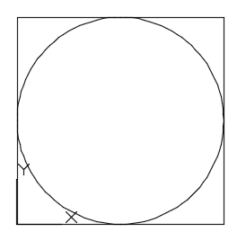Let’s turn our attention to the usefulness of the UCS or the User coordinate system. I want to draw a 4x4 rectangle with a 2 inch radius circle exactly in the middle. Let’s first draw the 4x4 rectangle.

How do I know where the circle should be placed? I just placed the rectangle using a click of the mouse and not with coordinate points. This is where the UCS is very useful. I will move my UCS to the corner of the rectangle creating a temporary origin.

Now I know my circle center should be placed at 2,2.

The UCS may also be rotated. This comes in handy when constructing an auxiliary view.

Have fun and explore. I’ll catch you in the next episode.

**Coordinates**

1. Absolute and relative coordinates

Hi and welcome to Engineering Essential’s AutoCAD instruction. In this episode we will be talking about the difference between absolute and relative coordinates. Absolute coordinates are measured with respect to or relative to the current origin. Whereas, relative coordinates are measured relative to the last coordinate point enter via the key board or mouse. Before we begin, let’s check to see what type of drawing we are in by using the commands UNITS and LIMITS.

1. Grid

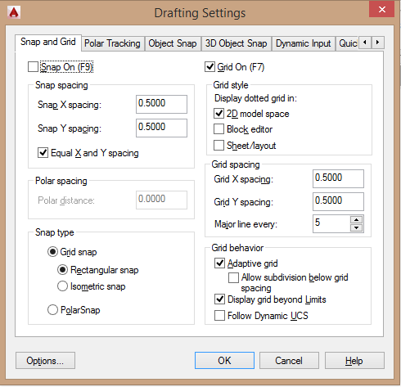Let’s start by visualizing the coordinate plane. AutoCAD gives us the option of showing a GRID, which places lines or dots at selected coordinate points. As you can see the grid shows our drawing area. To access the *Snap and Grid* options, type DSETTINGS in the command window. Here you activate the *2D Model Space* check box to get dots instead of lines and Display the grid beyond your limits among other settings.

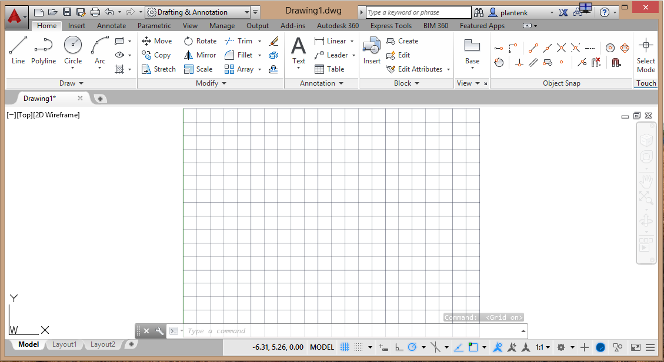

1. Draw a line using absolute and relative coordinates

Now onto the difference between absolute and relative coordinates. Let’s say that I want to draw a horizontal line that is 4 units long. If I start my line at 3,3 then it is easy to calculate what the end point should be. We just need to add 4 to the x coordinate and the line ends at 7,3. (Draw the line)

What if I don’t know where the first point of my line is? How do I know where to end the line? I can overcome this problem by using relative coordinates. Remember relative coordinates are relative to the last point entered. So if AutoCAD knows that I am entering a relative coordinate for the second point I just have to enter 4,0, but how do I tell AutoCAD that this is a relative coordinate? I use the @ symbol before the coordinate. Watch. (Draw the line)

1. Polar coordinates

So far all the coordinates I have entered have been Cartesian or x-y coordinates. Can AutoCAD handle other coordinates system? The answer is yes. We can use polar or r, coordinates. If I want to draw a line that is 3 units long at a 30 degree angle this is easily done using polar coordinates. The angle in a polar coordinate is preceded by a less than symbol. (Draw the line)

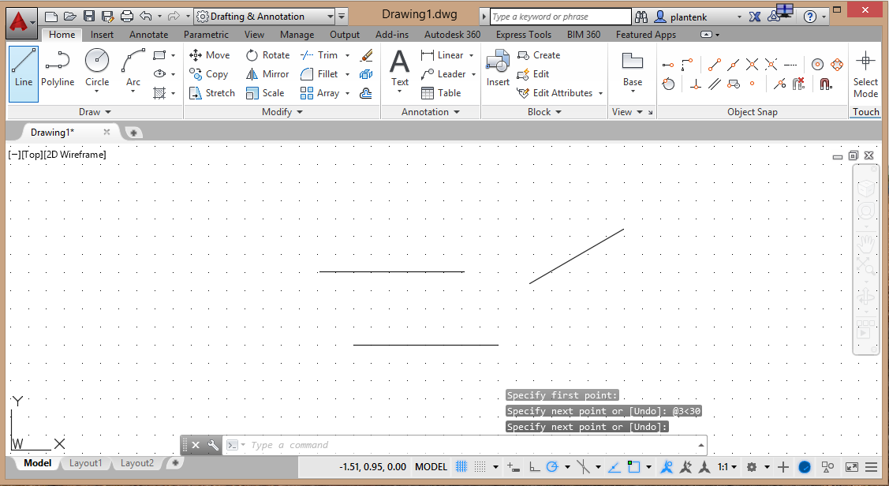

Have fun and explore. I’ll catch you in the next episode.

**Drawing**

1. Draw commands

Hi and welcome to Engineering Essential’s AutoCAD instruction. In this episode we will be taking a look at the *Draw* commands. (Expand and pin the *Draw* panel)

Some *Draw* commands are very simple with few or no options such as a LINE (highlight). There is really only one way to draw a LINE, you choose a start point and an end point. That’s it.

Other Draw commands are more complex and have many options to choose from. For example, there are many different ways to draw a CIRCLE.

You can enter a center point and a radius, a center point and a diameter, use three points to define it, etcetera.

1. Command prompt options

Notice that the *Draw* commands for ELLIPSE, ARC and POINT also have pull down options. Does this mean that the other commands don’t have any options? No.

Let’s use the RECTANGLE as an example. The RECTANGLE has many options; however, they all must be entered in the *Command* window. Let’s play around with a few of those options.

So, as you can see, a RECTANGLE can be much more than the typical horizontal straight sided rectangle that you are used to seeing.

1. Pull down options

When you use the pull down menus in the *Draw* panel to select how you want to draw a particular object, the correct options in command prompt will be selected automatically. You don’t have to manually input them like we did with the RECTANGLE. Notice this as we draw an ARC.

1. Tool tips.

Remember that if you are confused about a particular command in the *Draw* panel and what it does, hover your mouse over the icon and a tool tip will appear.

Have fun and explore. I’ll catch you in the next episode.

**Modify, Move & Copy**

1. Modify Commands

Hi and welcome to Engineering Essential’s AutoCAD instruction. In this episode we will be taking a look at the *Modify* commands. These commands allow you to adjust or change existing objects.

1. Move & Copy

The first *Modify* commands we will taking a look at are the MOVE and COPY commands. The most important concept to grasp when dealing with many of the modifying commands is the base point. When moving and copying objects, you will be asked to select a first and second base point.

Let’s move this circle 3 units to the left. In this case the first base point is unimportant. It can be any point as long as we use relative commands when we specify our second base point which in this case would be relative 1 angle 180.

Now let’s copy the same circle 1 units up and 1 units down. It is a very similar procedure, except the COPY command gives us the option of creating multiple copies.

What if we don’t know the exact distance that we want to move something, but we know that we want to move the center of the circle to the corner of the rectangle? In this case the first and second base points are chosen based on the object’s geometry. The first base point will be the center of the circle and the second base point will be the corner of the rectangle.

1. Rotate

The choice of base points also influences commands such as ROTATE. The ROTATE command only requires one base point. The point that the object will be rotated about. I will rotate this circle using its top quadrant as the base point.

1. Scale

The base point affects how an object gets SCALED. Let’s see.

1. Mirror

Let’s try the MIRROR command.

1. Extend & Trim

The TRIM and EXTEND commands are very useful. TRIM allows you to select a cutting edge and cut any object that intersects the cutting edge. And, the EXTEND command will extend an object to a boundary.

1. Fillet & Chamfer

The FILLET and CHAMFER commands are very similar. The FILLET command produced a rounded corner and the CHAMFER command produces a beveled corner.

Well, that’s a brief look at the most commonly used Modify commands. There is much more to explore. Have fun and I will catch you in the next episode.

**Text**

1. Where text commands are located

Hi and welcome to Engineering Essential’s AutoCAD instruction. In this episode we will be taking a look at how to create and modify text.

The text commands are located in the *Annotation* panel in the *Home* tab or the *Text* panel in the *Annotate* tab.

1. Mutiline text

There are two ways to enter text. You can use MULTILINE TEXT or SINGLELINE TEXT. Let’s start by entering some text using the MULTILINE TEXT command.

Once you have selected the MULTILINE TEXT command you are required to define an area where you want your text to go.

Then, you are able to type and edit your text. You will also notice that the *Home* ribbon tab has changed to a *Text Editor* tab.

* + Text styles

Notice the text font. This is AutoCAD’s default text. It doesn’t take much memory, but its very ugly. For presentation purposes, you usually want to change the font. To do this you edit your font style.

You can also enter this window by typing the word STYLE.

This window allows you to change your text’s font, height and the general default appearance.

Notice that the existing text has changed according to the settings that we entered in the *Text Styles* window.

Does this mean that all the text in a single document has to look the same? No. AutoCAD allows you to create multiple text styles.

*Text Style* window, make it a habit of checking the *Annotative* check box. You don’t know what this is for yet. It will be explained later. But for now, just make it a habit.

Let’s create some text using the newly created text style.

* + Editing text

To edit existing text, type DDEDIT in the *Command* window and then click on the text that you want to edit.

You can also edit text by double click on it.

* + Insert symbols

The *Text Editor* tab has a place where you can insert symbols into your text. This is very useful, because the trend in technical drawings is to replace all words with symbols. This eliminates the need for language translation.

1. Single line text

You can also insert text using SINGLELINE TEXT. This comes in handy mainly for numbers or single words that need to be placed precisely. For example, what if we wanted to place a word exactly in the middle of a circle? This can be easily accomplished with SINGLELINE TEXT. Watch!

Have fun and explore. I’ll catch you in the next episode.

**Selecting Objects**

1. Selecting

Hi and welcome to Engineering Essential’s AutoCAD instruction. In this episode we will be taking a look at selecting objects. I will be using the ERASE command to illustrate the various ways to select objects. (Select the ERASE command) Notice that when AutoCAD wants you to select an object, your crosshairs will turn into a pickbox. When you hover the pickbox over an object it will become highlighted gray and when you select an object it becomes highlighted blue. (Select several objects)

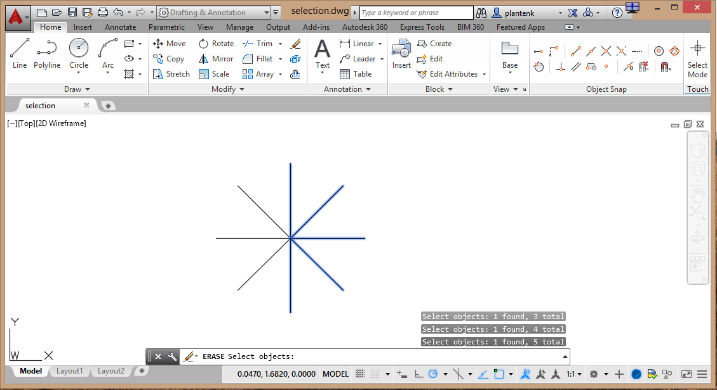

* + Removing and Adding

If you want to remove a selected object from the selection set, type REMOVE or R and then select the object to be removed. If you want to then add an object to the selection set, type ADD or A and then select the object to be added. (Remove and then add a few objects)

1. PICKADD

The PICKADD variable controls how objects are added to the selection set. Right now I have it set to 1 so that objects are just added to the selection set without affecting other objects already selected. Let’s change it to 0. Which means that only one object at a time can be in the selection set.

I’ll change PICKADD back to one.

1. Selection windows

You can also select object using a selection window. If you create a window from left to right only object that are completely within the window will be selected. Going right to left all object in and crossing the window will be selected. (demonstrate) The windows that I just created where click and release windows. If you click and hold you get a lasso window. The same rules apply. (demonstrate)

Have fun and explore. I’ll catch you in the next episode.

**Object Snap**

1. Object snaps

Hi and welcome to Engineering Essential’s AutoCAD instruction. In this episode we will be taking a look at object snaps. Object snaps are drawing aids that allow you to draw accurately and very quickly. Basically AutoCAD detects geometric features of existing objects and asks you if you want to snap to that location. For example, you can snap to an intersection between two objects, to the center of a circle or arc, or snap perpendicular to an object. The *Object Snap* panel shown is not, by default. If you want to see the panel, you will have to customize your user interface through the CUI command.

1. Using Object snaps

Using the geometry already present, let’s draw some lines using only object snaps.

Notice that when I hover the crosshairs close enough to the desired location an object snap marker will appear. This tells me that the point will snap to the intersection exactly. Don’t click until you see an object snap marker.

When we want to snap to the center of a circle or arc, we must briefly hover over the circumference of the circle or arc to acquire the center.

Notice that on the left side of the circles we went from quadrant to quadrant and on the right side we went from tangent to tangent. They may look the same at first glance, but on closer inspection they are different.

1. Automatically detect object snaps.

It can get pretty tedious going back and forth to the *Object Snap* panel every time you want to select a geometric location. So we can have AutoCAD automatically detect object snaps for us by activating the OBJECT SNAP icon in the *Status Bar*.

* + Settings

Does AutoCAD detect all the object snaps? What if I don’t want AutoCAD to detect all of them? Not a problem. We can tell AutoCAD what object snaps to automatically detect by right clicking on the OBJECT SNAP icon.

The object snaps that are checked will be automatically detected. Let’s enter the *Options* window and see what else we can set.

In the *Options* window we can set the size of the Object Snap markers and the size of the area in which AutoCAD will detect the geometric location.

* + Redraw

Now, let’s redraw the lines having AutoCAD automatically detect our object snaps.

Notice that AutoCAD does not automatically detect a deferred tangent. Therefore, we have to manually select it in the *Object Snap* panel or type the command in the *Command* window.

As you can see, with AutoCAD automatically detecting object snaps, drawing speed increases dramatically.

Have fun and explore. I’ll catch you in the next episode.

**Tracking**

1. Tracking

1) Hi and welcome to Engineering Essential’s AutoCAD instruction. In this episode we will be taking a look at tracking. Both polar tracking and object snap tracking.

1. Polar tracking

2) Polar tracking allows you to select points along polar tracking lines. To enable this, activate the *Polar Tracking* icon in the status bar.

3) Let’s draw a line with the assistance of polar tracking.

4) Notice that after I select the first point of the line a dotted polar tracking line appears. The mouse will preferentially snap to that line. Once you have acquired the desired tracking line, all you have to do is enter the length of the line in the command prompt. The line will stay in the direction of the polar tracking line.

* + POLARANG

5) So I have created two lines using a 0 degree and a 90 degree angle polar tracking line. Can I track angles in between? Yes you can.

6) At the moment, AutoCAD allows me to snap to angles at increments of 45 degrees. If you want an increment that is finer than that, you need to change the POLARANG variable.

7) Now I can snap to increments of 30 degrees.

1. Object snap tracking

8) What if I wanted to end this line at the midpoint of the bottom line and maintain still maintain a polar tracking line? Can I do that? Yes, by using object snap tracking. To enable this, activate the *Object snap tracking* icon in the status bar.

9) To end the line at the midpoint of the bottom line we must create an object snap tracking line from that point. The first step is to acquire that point. To acquire the point, hover the mouse over the point, but don’t click.

10) Then bring the mouse back to where you want the end of the line to be.

11) You can see that now we have both a polar tracking line and an object snap tracking line that defines where the end of the line should go.

* + Temporary tracking point

12) You can also create temporary tracking points by typing tt at the command prompt. Watch.

Have fun and explore. I’ll catch you in the next episode.

**Grip Boxes**

1. Accessing Grip Boxes

Hi and welcome to Engineering Essential’s AutoCAD instruction. In this episode we will be taking a look at grip boxes. To access an object’s grip boxes, just click on it.

1. Moving an object

To move an object, click on the center grip box.

1. Stretch

To stretch an object, click on the end or outer grip box. This is very useful for moving the grip box of one object to the snap point of another.

1. Shortcut menu

To access a grip boxes’ short cut menu, right click on it.

Have fun and explore. I’ll catch you in the next episode.

**Chapter 3: Creating Orthographic Projections in AutoCAD**

**Layers & Penwidth**

1. Creating a drawing template

Hi and welcome to Engineering Essential’s AutoCAD instruction. In this episode I will be taking you through setting up a drawing template that will have all the layers you will need to create an orthographic projection.

1. New drawing

We will start by opening a new metric drawing. Currently the units selected are inches. We need to change that to metric or millimeters. If we continue to set up our drawing using the Wizard from here, for some reason, AutoCAD will still think that we are in inches. Let’s take a look. Notice that the paper size is still 12 x 9. (Cancel the setup)

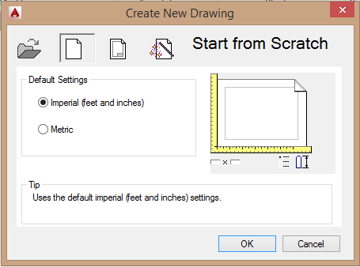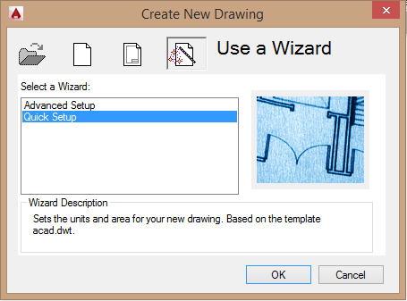

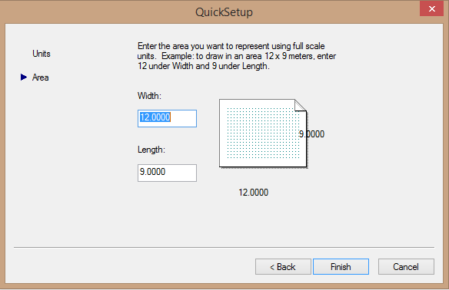

So what we need to do after we select Metric as our unit is to select OK and re-enter the *Create New Drawing* window and then re-open the window and continue from there. I don’t know why, but just keep this in mind if you need to change your units. Notice that now the size of the drawing is 420 x 297 which is definitely metric. We need to change that to a multiple of 8.5 x 11 which will be **280 x 216**.

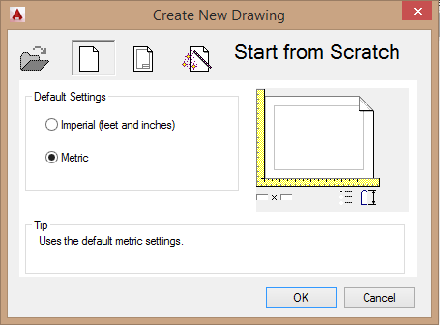 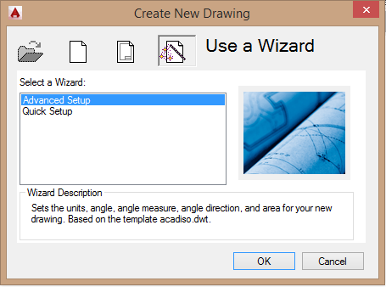

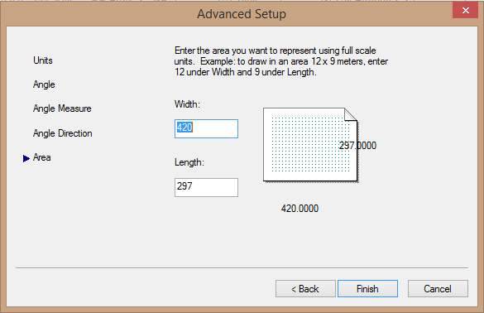

1. Layers

We need to create layers to keep our drawing organized, control line type and pen width. The *Layer Properties Manager* window is the place where we will create and organize all our layers. (Open this window) Each layer can have its own name, line type and color. The color controls the printed width of the line. Let’s create a couple of layers.

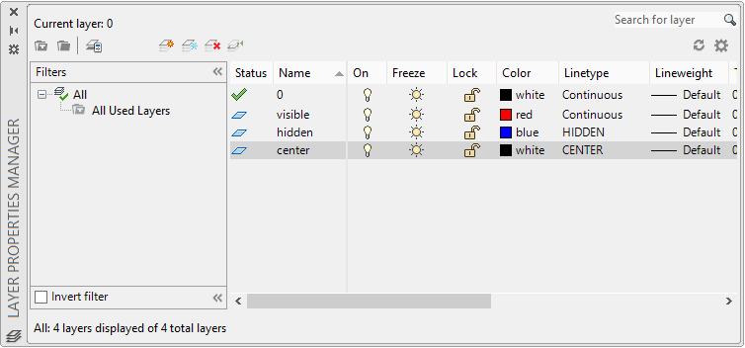

1. Draw lines on different layers

Let’s draw some lines on the different layers. The layer that we are drawing on at the moment is said to be current.

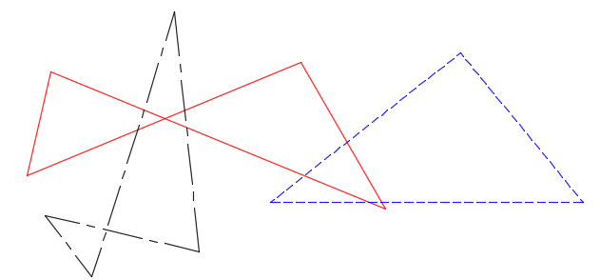

We can LOCK a layer so that the lines on that layer can be seen but not selected. We can also turn a layer OFF.

1. LTSCALE

Notice that some of the line types have dashes and spaces. The size of the dashes and spaces are controlled by the variable LTSCALE. Larger values mean bigger dashes and smaller values mean smaller dashes. (Change the ltscale) LTSCALE is a global variable. It affects all the lines. If you want to change the LTSCALE of an individual object, that can be done in its *Properties* window.

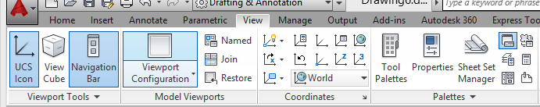

1. Printing

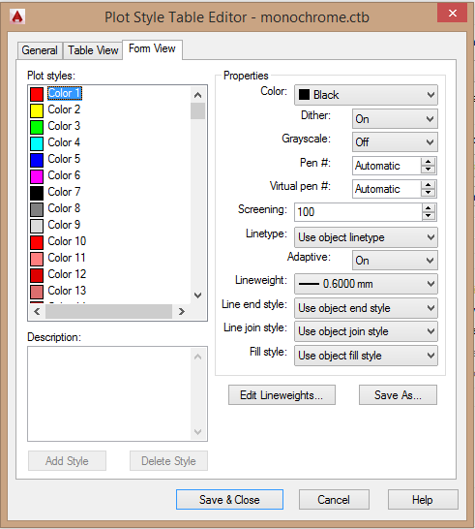How can we control the printed widths of our lines? We can do that in the *Page Setup* window. (Open the *Page Setup* window) When printing on a black and white laser printer, it is a good idea to pick the *Monochrome* pen style. (Open the Monochrome pen styles window) This is where we can match color to pen width. Each color is assigned a different pen width. The pen widths are stored in the computer and not the file, so if you change computers, you will probably have to re-enter the pen widths.

1. Save as a template

I am going to erase all the lines that I have drawn and save this drawing as a template file. The advantage of a template file is that it can be reused. Now that I have all my layers created, I won’t have to recreate them.

Have fun and explore. I’ll catch you in the next episode.

**Blocking**

1. What is a Block

Hi and welcome to Engineering Essential’s AutoCAD instruction. In this episode I will be talking about blocks. A block is a reusable object. For example, a bolt is a bolt. There may be minor differences, but you don’t want to draw every bolt in your drawing individually. So, we make a block of a generic bolt and reuse it thereby speeding up the drawing process.

Notice that the bolt drawing is made up of individual entities that can be easily edited. A block on the other hand is one entity.

* + Block panel

Most of the commands related to blocking may be found in the *Block* panel.

1. Create a block

Let’s create a block of the bolt.

We need to select the objects that will be part of the block.

* + Insertion base point

Next we need to select the insertion base point. This can be any point. However, it makes inserting the block easier if you make the point have some functional significance. For instance, the bottom surface of the head of the bolt usually contacts another part. So, we will choose the midpoint of that surface.

* + Annotative

We should make our block annotative so that it can support multiple view port scales.

And last but not least, we need to name our block.

1. Insert a block

Now that we have created our block, let’s insert it.

When we insert a block we can control its scale and rotation.

As you can see the inserted bolt is a copy of the original, but it is smaller and inserted at an angle.

1. Explode

Notice that the inserted bolt is one entity. If we need to edit this bolt, we first need to explode it in to its individual components.

1. WBLOCK

A block can be reused only in the current drawing. If we want to use a block in other drawings, we must first WBLOCK it. When we WBLOCK a block it creates a file on your disk that can be inserted into any drawing.

Now let’s close down the current drawing, open a new drawing and insert the bolt block that we wrote to the disk.

Have fun and explore. I’ll catch you in the next episode.

**Model & Layout Space**

1. Model space

Hi and welcome to Engineering Essential’s AutoCAD instruction. In this episode I will be talking about Model and Layout space. Model space is what we have been working in so far. It is where you create your drawings at a 1 to 1 scale. If you want, it is where you can print your drawings. However, it is much more convenient to print your drawings from Layout or what is known as Paper space. It is called Paper space because it shows you exactly what will be printed on your paper. What you see on the screen right now is a drawing that fits into a box that is 22 by 17 which is twice the size of a normal 11 by 8 and a half sheet of paper. Therefore, when we print this drawing we will need to print it at half scale.

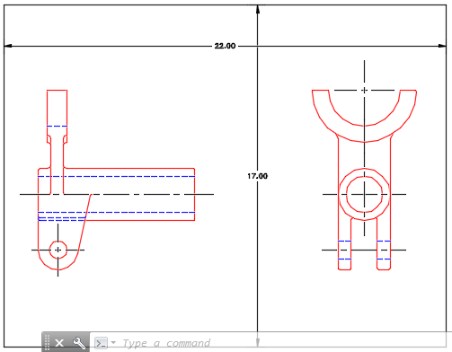

1. Layout space

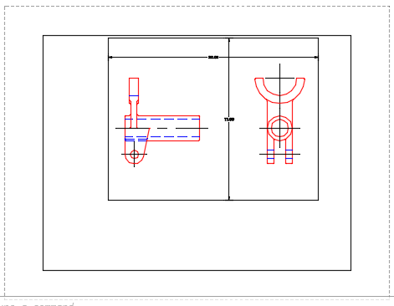Let’s enter Layout space and take a look around. Let me point out some of its features. Starting from the outside, the dashed line defines your printable area. Everything inside this border will print. Inside the dashed border is a solid border. This is the view port border. Layout space allows you to have multiple view ports, however, we will just use one for this demonstration. Inside the view port, you can see the drawing that we created in model space.

Before we print a drawing we usually would like to insert a title block. (Insert a title block)

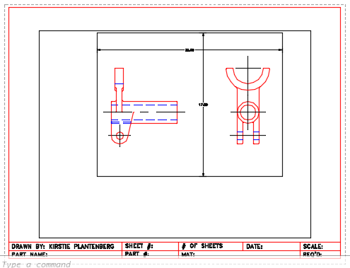

1. View port scale

Our drawing is small. We probably want it to be a bit bigger before we print. Before we play with the drawing scale, let’s make our view port border about the size of our title block. Notice down at the bottom there is a view port scale readout. Let’s change that to 1 to 1. That’s a little too big. Try 1 to 2.

* + Enter model space

That looks better, but it’s off center. We need to PAN it from within Model space and get it centered. To enter Model space from within Layout space, double click inside the view port border.

Have fun and explore. I’ll catch you in the next episode.

**Printing**

1. Printing from Layout space

Hi and welcome to Engineering Essential’s AutoCAD instruction. In this episode I will be talking about printing from Layout space. Before we print, we should do a few things. One, check our view port scale, indicate that scale in our title block and hide our view port border. I usually do this by creating a layout layer, placing the view port border on that layer and then just turning that layer off.

It looks like we are ready to print.

In the *Plot - Layout* window we are always going to plot the layout. This is different from printing from Model space where we have several different printing options. And, we will always print at a 1:1 scale. The actual scale is taken care of by the view port scale. Before you actually print it is always a good idea to look at the print preview.

1. Metric

The last drawing we looked at was in inches, the drawing that we are viewing now is a metric drawing. Are there any differences when it comes to printing from Layout space? Let’s find out.

The first thing you should notice is that the shape of the paper is not the same proportions as a standard 8 and a half by 11 sheet of paper. If you plan on printing on a normal sheet of paper, you will need to change this in the *Page Setup* window.

Now let’s insert a title block. Since my title block was drawn in inches, I will have to scale it up by a factor of 25.

Then we go through the same steps as before to prepare our drawing to be printed.

Notice that we are still printing the layout, but the print scale is not 1 to 1. This is because we are printing a metric drawing.

Have fun and explore. I’ll catch you in the next episode.

**Chapter 15: Creating Isometric Pictorials in AutoCAD**

**Creating Isometric Pictorials**

1. Isometric Pictorial setup

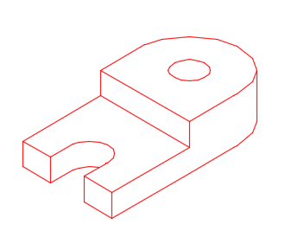Hi and welcome to Engineering Essential’s AutoCAD instruction. In this episode I will be talking about isometric pictorials. Isometric pictorials are 2-D drawings that look three dimensional. For example, the drawing shown is an isometric pictorial. Notice that the sides of the objects are angled 30 degrees off the horizontal. Also, the circles are not really circles, they are ellipses.

So let’s set up a drawing environment to create an isometric pictorial. I never draw an isometric pictorial without a grid. Let’s activate the Isometric snap. (activate in Status bar) Notice what this did. The grid and crosshairs are now angled. This makes it much easier to create those angled sides.

1. 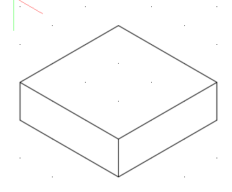Draw linear features

Let’s draw a simple box using the grid and isometric snap as a guide.

1. Draw circular features

We noted before that circular features such as holes are not circular, but elliptical. AutoCAD has a special kind of ellipse designed for drawing isometric pictorials called isocircles. Let’s place a hole on the left side of the block.

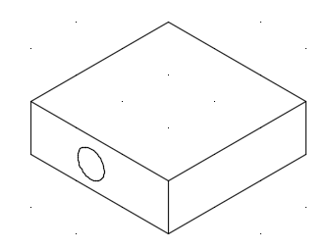

If I wanted to place a hole on the top face, it wouldn’t look right. Notice the direction of the crosshairs. At the moment, they are toggle to the left face. To toggle them to the top select the correct orientation in the *Status Bar*.

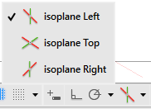 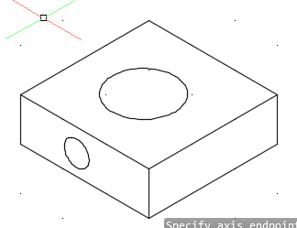

I try to draw the majority of my isometric pictorial with the snap on, however, when this no longer works, I use polar tracking with the POLARANG variable set to 30 degrees.

Have fun and explore. I’ll catch you in the next episode.

**Chapter 5: Dimensioning in AutoCAD**

**Creating Dimensions**

1. Dimension commands

Hi and welcome to Engineering Essential’s AutoCAD instruction. In this episode I will be showing you how to create dimensions and adjust your dimension style. In general dimensions are associative and annotative. The difference between the two will be talked about much more in an upcoming episode. But basically, associative dimensions change their value if the size of the part changes. And, an annotative dimension changes its size, the size of its text, arrow heads, etc, based on the current view port scale.

The dimensioning commands may be found in the *Annotation* panel in the *Home* tab or in the *Annotate* tab.

I usually do most of my dimensioning from the *Home* tab, because that where I spend most of my time. That is unless I need a specialized dimensioning command that forces me to travel to the *Annotate* tab.

1. Creating dimensions

Let’s start by creating a few linear dimensions. When you dimension a feature, you are required to select two points to measure between. This is a quick task if you activate your *Object Snap*.

Once you have selected your two points, pull your dimension away from the part and click to place it. You should always accept the default text otherwise the associativity of the dimension is broken. You can always go back later and edit the dimension text.

Let’s place a couple more horizontal dimensions and a couple vertical dimensions.

Now let’s create a diameter and a radius dimension. All this requires is the selection of the circle or radius. AutoCAD automatically points the dimension to the center of the circle or arc.

Now let’s create an angular dimension.

1. Dimension style

Notice that the standard used to create these dimensions is the ISO-25 standard. This is not the standard that we follow in the United States. We follow the ASME standard. We need to adjust our dimension style to conform to the ASME standard.

We will create a new ASME dimension style using the ISO-25 standard as a start point and make our new style annotative.

Change the precision to 0 decimal places and the decimal separator to a period.

Deactivate the ‘Draw dimension line between extension lines’ check box. This will eliminate the line that is draw to the center of a circle or arc.

Make all the text horizontal and force the dimension text between the dimension line instead of above it.

Eliminate the center mark that is created by the diameter and radius dimensions. I find that this can interfere with the centerlines that are already drawn.

Now let’s make our new ASME style current.

Notice that the current dimension style is ASME. So, any dimension that we draw will conform to this style. But, how to change the previously drawn dimensions to the new style. We use the UPDATE command located in the *Annotate* tab.

Now all the dimensions conform to the ASME style that we defined.

1. DIMTIX

One last useful command before we leave. Look at the dimension on the right by itself. The dimension text is not between the extension lines. Personally, I like my dimension text to be between the extension lines even if this means that the arrow heads have to go outside. To force this to happen, we need to turn the variable DIMTIX on and UPDATE the dimension. Watch.

Have fun and explore. I’ll catch you in the next episode.

**Multileaders**

1. Dimensioning using leaders

1) Hi and welcome to Engineering Essential’s AutoCAD instruction. In this episode I will be showing you how to dimension a feature using a leader line and note. Leaders are created using the MULTILEADER command in AutoCAD. Multileaders may be Annotative but are not Associative.

2) Commands related to Multileaders are located in the *Annotation* panel in the *Home* tab or in the *Annotate* tab.

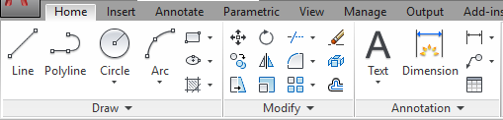

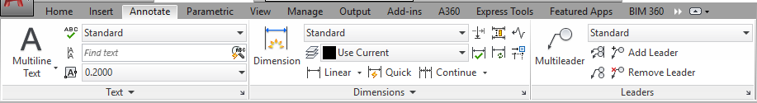

3) Let’s dimension the 5 X 5 chamfer using a leader and note.

1. Multileader style

4) Notice that there seems to be no text or arrowhead. Well there is, it is just really small. We will need to adjust the Multileader style and correct those parameters.

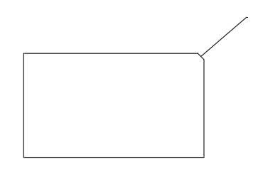

5) We will create a new ASME style that is Annotative.

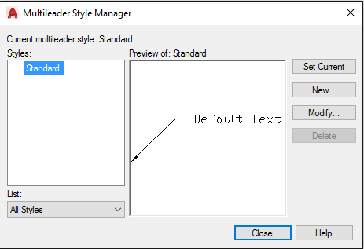

6) Before we get in and adjust our Multileader style, let’s take a look at the structure of a leader. First we have the arrow head that points to the feature we wish to dimension, a straight angled line, then a short horizontal line that is called the landing. Between the landing and the text is the landing gap. The text may also be attached to the landing in different ways.

7) We should set our new ASME style current.

8) Unfortunately, Multileaders cannot be updated. So, we will need to erase and redraw.

Have fun and explore. I’ll catch you in the next episode.

**Associativity & Annotative Objects**

1. Associative and Annotative objects

Hi and welcome to Engineering Essential’s AutoCAD instruction. In this episode I will be talking about Associativity and annotative objects. Previously when we have created text and dimensions I told you to select annotative. Now we will find out why. If an object has Associativity that means it is associated and will change with the geometry that it is attached to. On the other hand an annotative object will change its size based on the current view port scale.

1. Associativity

Let’s start by talking about Associativity. Most of the dimensions that you see here are associated with the geometry that they measure. That means if I change the size of the part the values of the dimensions will change. Take note of the 30 mm linear dimension, the 12 mm diameter dimension, and the 5 X 5 chamfer dimension. Now, I’m going to scale the part by a factor of 2. Notice that the values of the dimensions have doubled. The 30 mm dimension now reads 60 and the 12 mm diameter dimension now reads 24. That is Associativity. Notice that the value of the Multileader did not change and its size got scaled with the part. Multileaders are not associative. If you scale your part in this way, you will have to redraw your multileaders. (undo scale)

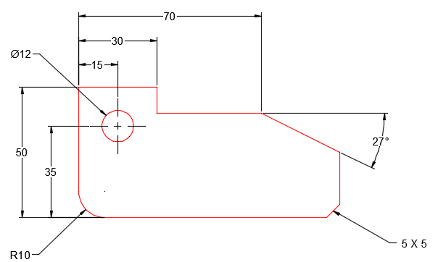 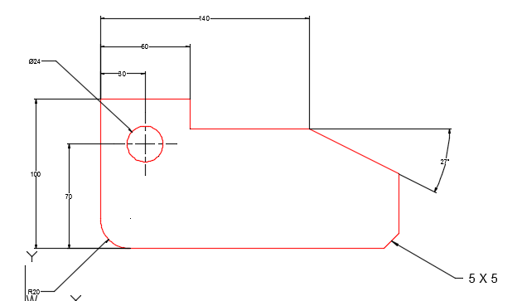

1. Annotative objects

Now let’s take a look at what an annotative object is. How do we know if an object is annotative. Just hover your mouse over the object and if its annotative, the annotative symbol will appear. Both the dimension and multileader styles that have been created are annotative.

* + Change view port scale

We need to enter the Layout space to see how annotative objects work. (enter layout space) Let’s adjust our view port size and shown our drawing at a 1:1 scale. If we print now, the dimension text would be 3 mm high, but the part itself is a bit small. It would be nice to double the size of the part. But does this mean that the text height would double as well? Not if your dimensions are annotative. We can double the size of the printed part and still have 3 mm high dimension text and I will show you how. Let’s change the view port scale to 2:1. The part is a good size, but it appears that all of our dimensions have disappeared. That’s because, at the moment, the dimensions don’t support a 2:1 scale. If we click on the *Annotation Visibility* icon in the status bar, we can view all the dimensions even if they don’t support the current scale.

* + Add support scale

Let’s add a 2:1 scale support to the 70 mm dimension. If we where to print our drawing now, the 70 mm dimension text would print 3 mm high and the rest of the dimension text would print 6 mm high. I will add the current scale support to the remaining dimensions.

Now we can change back and forth between a 1:1 scale and a 2:1 scale and the dimensions will automatically adjust their size.

Have fun and explore. I’ll catch you in the next episode.

**Editing Dimensions**

1. Adding diameter symbol

Hi and welcome to Engineering Essential’s AutoCAD instruction. In this episode I will be showing you how to edit the dimension text of existing dimensions. Take a look at the object shown. The first dimension that we will edit is the diameter dimension of the cylinder. Because it was created using a linear dimension, AutoCAD didn’t realize it needed to have a diameter symbol in front of the number. We will go in and add that. To edit the text of an existing dimension type DDEDIT and select the dimension.

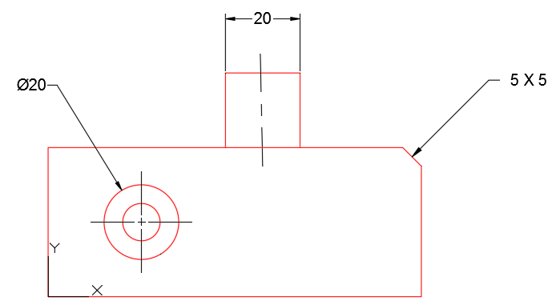

1. Adding a degree symbol

Now we will change the Chamfer dimension from 5 X 5 to 5 X 45 degrees and add a degree symbol.

1. Adding GDT text to a C’BORE

The last dimension is dimensioning a counter bore and drill. A counter bore is a flat bottomed hole designed to recess the head of a bolt. A counter bore dimension has three components: the diameter of the drill, followed by the diameter of the counter bore and finally the depth of the counter bore. What you see now is only the diameter of the counter bore. There is no way for AutoCAD to know that this is a counter bore and drill, so we need to add that information. First we will add the counter bore symbol in front of the existing diameter to distinguish it from the drill diameter. This symbol is added using the GDT font and the letter that will give us that symbol is v.

Next we will add the drill diameter. Make sure you switch your font back to Arial or whatever font you normally use.

Finally we will add the depth of the counter bore. Again we need to use the GDT font and the letter x to obtain the proper symbol for depth.

* + Justification

Let’s change the justification to flush right.

Have fun and explore. I’ll catch you in the next episode.

**Chapter 7: Sectioning in AutoCAD**

**Sectioning**

1. Creating a cutting plane line

Hi and welcome to Engineering Essential’s AutoCAD instruction. In this episode I will be talking about sectioning. More specifically, how to draw a cutting plane line and add section lines to your drawing. For the part shown, I want to cut the top view and change the front view into a full section view.

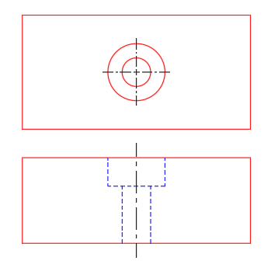

The first thing that we need to do is draw the cutting plane line and show where the part is being cut. This is as easy as changing our layer, drawing a line and adding leaders to the end of the line. If you have created a template file, you should have a layer that contains the phantom line type. This is the layer we will draw the cutting plane line on.

Notice that the cutting plane line overlaps the existing center line. Cutting plane lines take precedents over center lines; therefore, we need to erase the center line.

Now let’s extend the cutting plane line past the visible boundary of our part.

* + Multileader style

The next step is to add arrow heads to the ends of the cutting plane line which will indicate the direction of sight. We will do this using Multileaders. We will have to create a special Multileader style to accomplish this task. One with no landing and an arrow head twice the normal size.

1. Changing line types

Now let’s create our section view. We need to change our hidden lines in the front view to visible lines. This is just a matter of selecting the lines and moving them to the visible layer.

1. Drawing section lines

The section lines will be placed in the areas where material has been cut. I usually place by section lines on the Dimension layer. They print with the same pen width and line type. However, you may want to create a separate layer for your section lines.

To create the section lines, select the HATCH command.

In the *Hatch Creation* ribbon we can select the section line symbol or pattern, the scale or the distance between the lines and the section line angle. Any value placed in this box will either be added to or subtracted from the default angle of 45 degrees. And you usually want to make your section lines annotative.

* + Methods of placing section lines

There are two methods for selecting the area in which you want to place your section lines. Let’s try the *Select Boundary Objects* method first.

Well that’s probably not right.

Let’s try the *Pick Points* method now.

That’s more like it.

* + Editing section lines

If you want to edit section lines after they have been created, just double click on them.

1. Annotative

Section lines may be defined as annotative. Which means that the scale or the distance between the lines will adjust based on the view port scale. I have added a support for the scales 1:1, 2:1 and 1:2 to the HATCH. Let’s switch between them and see the effect.

Have fun and explore. I’ll catch you in the next episode.

**Chapter 9: Tolerancing in AutoCAD**

**Tolerancing**

1. Ways of creating a toleranced dimension

Hi and welcome to Engineering Essential’s AutoCAD instruction. In this episode I will be talking about how to create toleranced dimensions. There are basically two methods of creating a toleranced dimension. You could create a new ‘Tolerance’ dimension style and use that to create your dimensions. Or you could Override your current dimension style temporarily in order to create the toleranced dimensions you need.

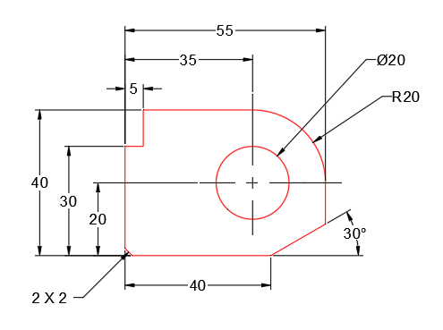

1. New

Let’s start by creating a new ‘Tolerance’ dimension style. We will look at all the options and what can be changed. In the *Tolerance* tab, you should set the tolerance method, your precision, and the upper and lower values. The vertical position is the position of any diameter or radius symbol relative to the limits. It also controls the position of the basic size if you are using the deviation method. And, don’t forget to deactivate the ‘Suppress trailing zeros’ and or your dimension won’t look toleranced at all.

* + Go over the different tolerance methods.
  + Go over precision. Set to .001
  + Go over Upper and Lower value. These are the values that will be added to and subtracted from the basic size. Therefore, if I put a negative value in to the lower value field, it will actually be added to the basic size.
  + Let’s say that all the dimensions using this style are allowed to vary +.001 and -.002.

1. Override

Now let’s go over how to override your dimension settings. We will use the ASME style. Modifying the ASME style is more or less permanent. Overriding the ASME style temporarily changes the style settings.

Notice that none of the dimensions have changed. That’s because we didn’t change the ASME style, we just temporarily overrode it. To make the changes take effect, we must UPDATE the dimensions we wish to be toleranced.

Any dimension drawn while the override is still active will have the same tolerance properties.

To cancel the override, just make the ASME style current again.

Let’s override the ASME style again and try a different type of toleranced dimension.

Have fun and explore. I’ll catch you in the next episode.

**Chapter 13: Creating Assembly Drawings in AutoCAD**

**Assembly**

1. Moving using base points

Hi and welcome to Engineering Essential’s AutoCAD instruction. In this episode I will be taking you through some assembly basics. What you see is are several part that make up an assembly. (describe the assembly) To get these individual parts from their drawing file into one file, all you need to do is copy and paste.

After you have all the parts in one file the next step would be to move them into their functional position. We will use the MOVE command to do this. The only tricky part is choosing the correct base points. You have to find a point on the first part that touches a point on the second part. And, not only that they need to be object snap points. So let’s move some of the parts into their functional positions.

1. Clean up

Now we need to clean up any overlapping lines and change some line types. The TRIM and EXTEND commands are very useful when cleaning up an assembly drawing and you may find it necessary to turn some layers OFF temporarily. For this assembly we need to delete the overlapping lines of the bolt and the threaded hole.

Now let’s change the visible lines of the bolt to hidden.

1. Ballooning – New Multileader style

This assembly may have been more effective as a section, but we will leave it as is. The last thing that we will do is identify and locate the parts with ballooning. We need to create a new Multileader style for this.

Balloons should be in straight horizontal or vertical rows to make everything look neat. This is easy to do with the ALIGN LEADER command.

There is much more to creating a complete assembly drawing, but those are some of the basics. Have fun and explore. I’ll catch you in the next episode.